Report
“Developing the Roadmap on Engineering Qualification Standardization-
Preparing Future Engineers for Sustainable Development
in Asia-Pacific and ECO Region”
(9th -10th January 2015, Islamabad, Islamic Republic of Pakistan)

An international conference preceded by a national dialogue on developing the roadmap on "Engineering Qualification Standardization- Preparing Future Engineers for Sustainable Development in Asia Pacific and ECO Region" was organized in Islamabad- Pakistan on 10th January 2015. The conference was jointly organized by UNESCO Regional Science Bureau, Jakarta- Indonesia, UNESCO- Pakistan, ECO Science Foundation (ECOSF), Pakistan Engineering Council (PEC), the International Science, Technology and Innovation Center for South–South Cooperation under the auspices of UNESCO (ISTIC), the Federation of Engineering Institutions of Asia and the Pacific (FEIAP). The delegates representing academia and industry from the Republic of Azerbaijan, Republic of Kazakhstan, Republic of Tajikistan, Republic of Turkmenistan, Malaysia, IR of Pakistan as well as from collaborators ECOSF, PEC, UNESCO, ISTIC and FEIAP participated in the conference. The list of the participants is at Annex-I.

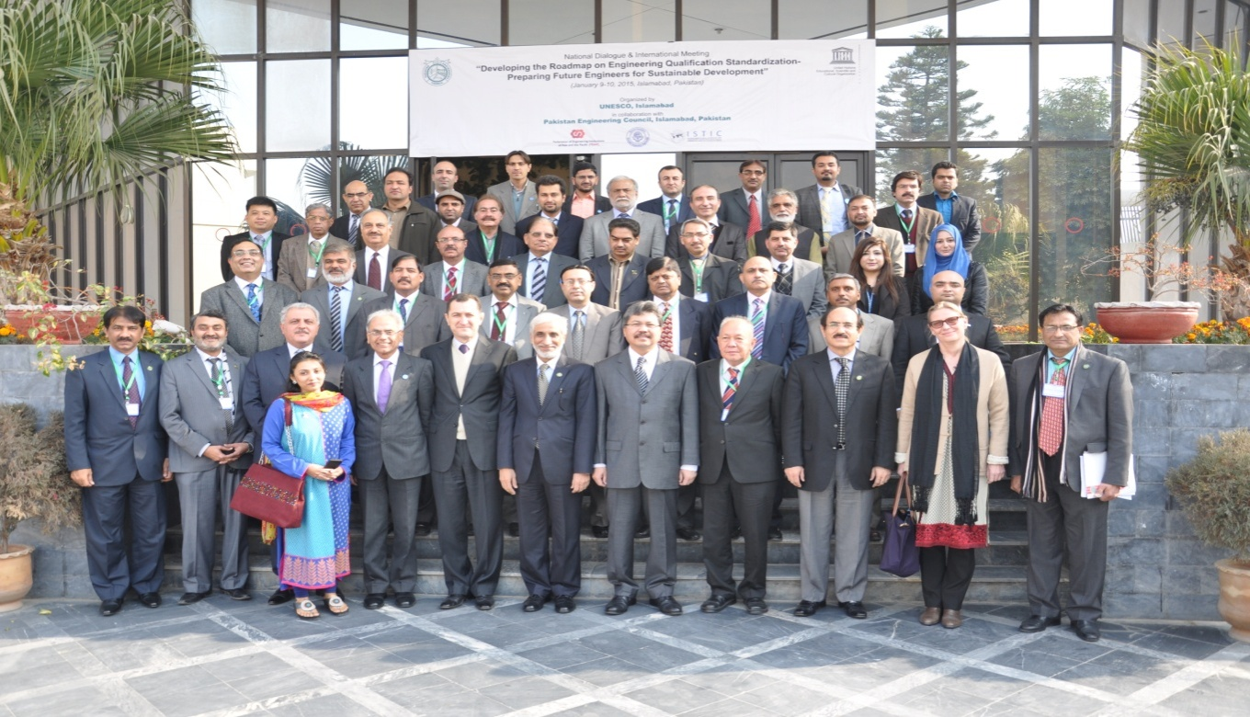
The objective of the conference was to provide a platform for the stakeholders in the region to share their work and help to formulate a comprehensive plan towards standardization of engineering qualifications as per international standards in Pakistan, ECO and Asia Pacific Regions recognizing the important role of engineers in planning, designing, construction, infrastructure and their lead role in ensuring sustainable economic development through innovations and improved systems. The conference was mainly sponsored financially by the Government of Malaysia through MoU between Malaysia and UNESCO Jakarta.
10th January, 2015 - International Meeting - Developing the Roadmap on Engineering Qualification Standardization
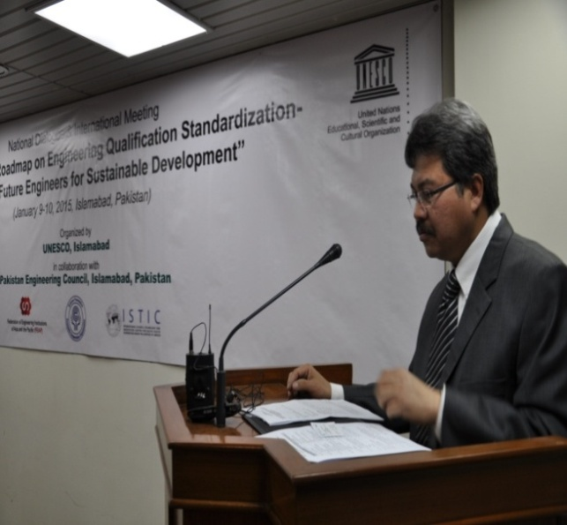
Chief Guest of the International meeting was H.E. Dato Dr. Hasrul Sani bin Mujtabar, High Commissioner of Malaysia to Pakistan. The Malaysian High Commissioner in his remarks said that Malaysia is strong supporter of UNESCO and has launched a Malaysian Fund in Trust, for capacity building in education, science and culture. The Trust Fund Agreement has been signed with UNESCO and this meeting is part of south-south cooperation which is part of Malaysian policy. He said that closer collaboration and cooperation must be enhanced through warm and cordial relationship between Malaysia and Pakistan but also other countries in the region. Elaborating the Malaysia-Pakistan cooperation, he said; "the close link between Malaysia and Pakistan has mainly been that of import and export of Basmati Rice and Palm oil, but I am pleased of this initiative where engineers of the brotherly countries will work closely with each other".
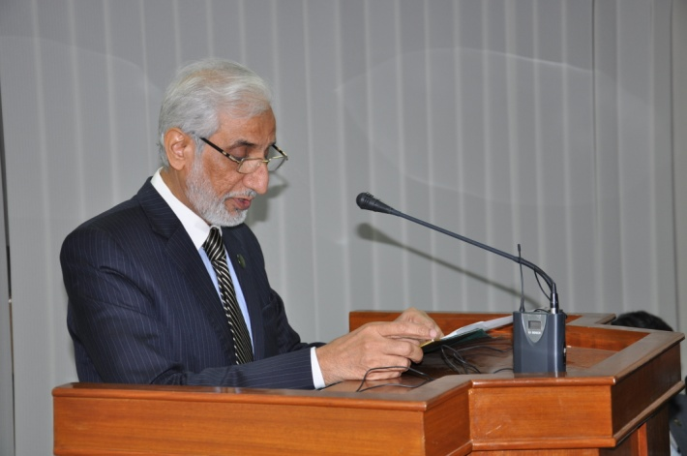
Syed Abdul Qadir Shah, Chairman, Pakistan Engineering Council there is a real need for standardization of engineering qualification in this era and this meeting will provide a platform for addressing the engineering problems and issues, enabling the engineers for their across the border contribution.
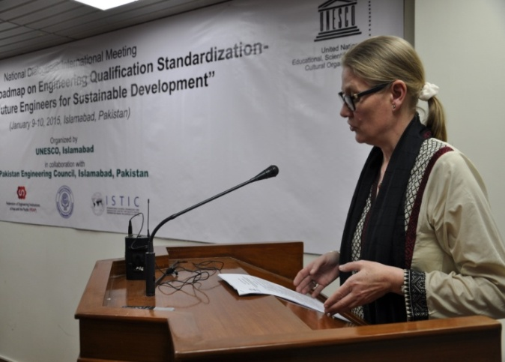
Ms. Vibeke Jensen, Representative/ Director, UNESCO-Pakistan thanked all the participants and emphasized that the initiative had meant to encourage and inspire academicians, particularly in Pakistan and other countries of Asia-Pacific towards harmonizing the engineering qualification standards with the international standards.
She underlined the active linkages between academia and industry as the significant factor that can accelerate industrial development in the region.
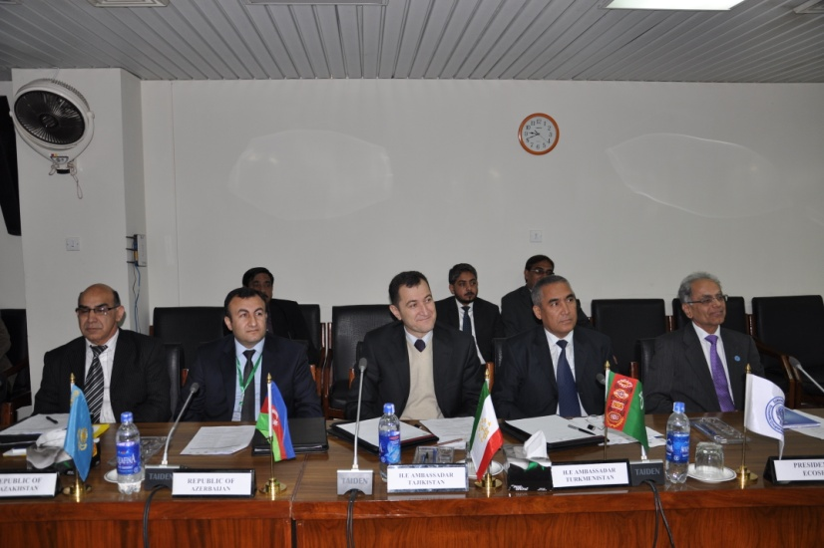
Senior officials from FEIAP, ISTIC, ECOSF and academicians of various Engineering Universities from Pakistan highlighted the importance of the initiative, key areas of progress and challenges and mentioned that PEC has great capacity to take the lead especially in the Asia Pacific region.

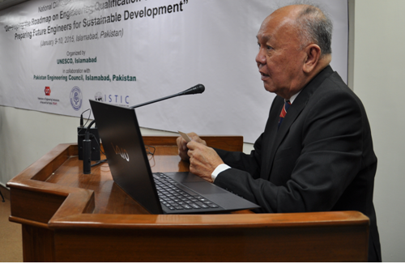Dato’ Ir. Dr. Lee Yee Cheong, Chairman, ISTIC Governing Board, Malaysia while stressing the need for standardization of engineering qualification suggested that UNESCO should take lead for implementing Washington Accord (WA) in member countries especially in Asia Pacific region. He proposed that UNESCO, FEIAP and ISTIC should sign an agreement to work jointly for engineering standardization.
He also shared the objectives & achievements made so far by ISTIC for promotion of South-South Cooperation. He emphasized on grass root level work like IBSE (Inquiry Based Science Education) from Kindergarten/ Pre-nursery level for quality input for engineering disciplines. He appreciated the vision of President ECOSF Dr. Manzoor Hussain Soomro for IBSE initiatives in ECO member countries

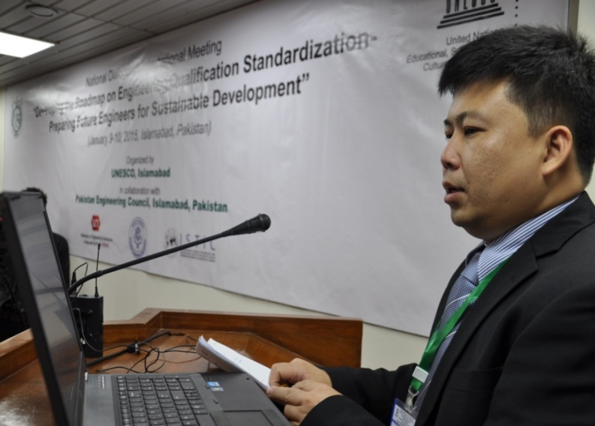
Ir. Dr. Tan Chee Fai, Faculty of Mechanical Engineering, University Teknikal Malaysia, FEIAP Representative, on behalf of President FEIAP, stressed the need of engineering qualification standardization as per international standards and accreditation process for mobility of engineers across borders.
Accreditation is important for continuous improvement of delivery of education for producing human resource needed for nations' development.

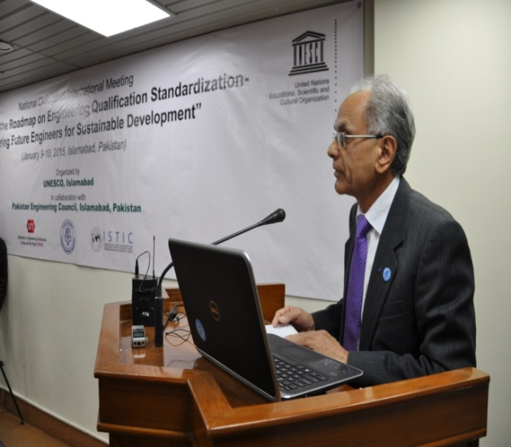
President ECOSF, Prof. Dr. Manzoor H. Soomro in his remarks thanked all the international delegates and participants from within Pakistan. He appreciated the collaboration among ISTIC, FIEAP, UNESCO, PEC and ECOSF for holding the international conference on engineering standardization. He paid his highest gratitude to people & Government of Malaysia for providing financial support for the conference through UNESCO. Dr. Soomro shared the plans and programs of the ECO Science foundation with emphasis on cooperation and collaboration leading to commercialization of the research results and economic development in the ECO region.
In his closing remarks, Shahbaz Khan, Officer In-Charge, UNESCO Regional Science Bureau for Asia-Pacific, Jakarta said that UNESCO has a long history of promoting internationally-recognized standards for engineering institutions and would like to continue to do so in countries like Pakistan to bring them to the level of international universities and to meet the global demands.
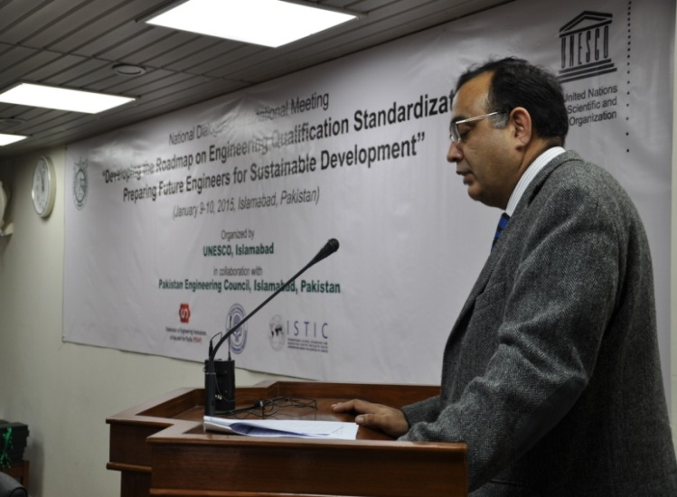
Dr. Khan also emphasized that there is a need to find new ways of learning, teaching, curricula improvement, and execute faculty trainings. He added that Pakistan has to take the lead for this initiative and help other pilot countries. There is a need to link with ECO countries and other member economies of Asia Pacific Region.
During the two day event, engineering experts, industrialists, academicians and focal persons from various national and international entities discussed gaps and opportunities and the development of a road map for engineering qualifications standardizations.
Pakistan has been selected as pilot case study for UNESCO-FEIAP collaboration which is working to improve the standards of engineering qualification in universities and institutes of higher education, in association with the engineering bodies. UNESCO & ECOSF agreed to assist FEIAP to champion its guidelines.

9th January, 2015 - National Dialogue
Earlier on 9th January 2015, a National Dialogue was organized which brought representatives from universities, institutions of Engineers and Industry across the country to develop a national consensus for making engineering qualification as per international standards.
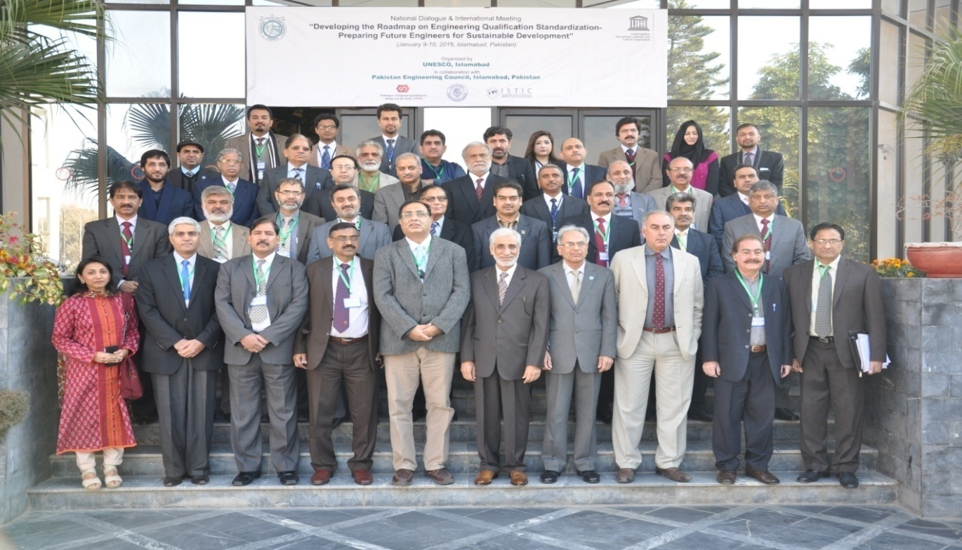
Chairman PEC Engr. Syed Abdul Qadir Shah welcomed the participants and gave an introduction of the meeting with the hope that outcomes of the dialogue will be useful for standardization of engineering qualification in the region.

President ECO Science Foundation (ECOSF) Prof. Dr. Manzoor Hussain Soomro in his opening remarks appreciated all collaborators for joining hands for the initiative. President ECOSF briefed the participants about Economic Cooperation Organization and ECO science foundation as specialized agency of ECO, established in Pakistan in December 2011. The main objective of ECOSF is to promote scientific and technological research based innovation, leading to economic development.

Dr. Soomro further highlighted the importance of ECOSF agreement with ISTIC and the potential of Central Asia for collaboration / partnership in various areas of S&T from which the whole region can benefit a lot. Pakistan Engineering Council (PEC), he said, has great potential to take the lead especially in the Asia Pacific region for standardization of Engineering Standards.

Officer in Charge, UNESCO Regional Science Bureau for Asia and the Pacific, Jakarta Dr Shahbaz Khan in his remarks briefed about UNESCO and said that UNESCO is an intellectual agency of United Nations and 2015 is 70th year of UNESCO. This is an important meeting for UNESCO. Its special emphasis is on science, education, culture and communication. He highlighted that the main aim of the engineering initiative is to strengthen engineering education, training and continued professional development, Standards, Quality Assurance and Accreditation.

Dr Shahbaz while stressing the need for the Standardized Engineering Accreditation Process and Standards recommended various to dos:
  - Transformation of Engineering Education
  - Shift toward Problem-Based Learning (PBL)
  - Rapid curriculum renewal considerations
  - Partnership among engineering educational institutions and encouraging fellowships for applied research and training
  - Fostering stronger university-industry partnerships
  - Fostering innovation through such partnerships and through establishment of science parks and similar hubs of scientific exchange and excellence

Dr. M. A. Kundi Executive Director HEC assured ECOSF, PEC and UNESCO of their full support in all initiatives towards standardization of engineering qualifications.

Technical Sessions & Discussions:-
The academicians / Engineers in their respective remarks shared details about their respective universities strengths & challenges in the context of Standardization of Engineering Qualification & Standards:-

The highlighted challenges were:-
  - Strengthening / Development of Regulators and Accreditation Agencies in the region
  - Training of assessors of engineering programs
  - Local academia to academia linkages
  - Cross border academia to academia linkages
  - Academia to industry linkages
  - Training of Faculty and Capacity Building
  - Integration of Society & Engineering
  - Different eligibility / selection criteria for students in HEIs
  - Different Grading System
  - Consideration of area specific challenges of HEIs
  - Practical realities of different areas need to address
  - Continuous Practical Development of Engineers
  - Lack of Co-learning
  - Limited resources i.e lack of modern laboratories
  - Limited research, consultancy & Industry interaction by HEIs
  - Lack of presence of any code of ethics for engineering profession

At the end of two days conference a declaration was adopted and working groups formed to materialize the action plan agreed.

Islamabad Declaration on Engineering Qualification Standardization

National Dialogue and International Meeting on Engineering Qualification Standardization was held on 9-10 January, 2015 in Islamabad hosted by UNESCO, Islamabad and Jakarta, Pakistan Engineering Council (PEC), the International Science, Technology and Innovation Center for South–South Cooperation under the auspices of UNESCO (ISTIC), the Federation of Engineering Institutions of Asia and the Pacific (FEIAP) and Economic Cooperation Organization Science Foundation (ECOSF). The meeting attracted more than 50 participants.

Under the main theme ‘Developing the road map for engineering qualification standardization’, four sessions devoted to national initiatives and regional perspective of engineering qualification standardization, engendered animated and constructive deliberation, culminating in the recommendations and outcomes in this Islamabad Declaration. The Islamabad Declaration was adopted by the participants of the international meeting on engineering qualification standardization on 10 January, 2015.

This Islamabad Declaration reaffirms that, standardization of engineering qualification is very important for the economies to promote their engineers all over the world. A strong linkage between the stakeholders in this regard is instrumental. That engineers not only assures the human resource pipeline required for the green and clean scientific, engineering and technology devices and systems needed to combat the challenges of global poverty and global climate change, but also provides the world with a rational and discerning citizenry that will help ensure peace and security of the world.

Therefore the Islamabad Declaration now:

- Calls on all engineering councils/associations to redouble their commitment to engineering qualification standardization, including reaching out to their national ministries of education and relevant parent departments.
- Calls on industry to assist engineering councils/association and their national governments to enhance education policies and initiatives to ensure the formation of the creative and innovative human capital that will enable their own enterprises to remain competitive in the increasingly fast-paced science and technology development environment.
- Calls on foundations and donors to sponsor the roll-out of engineering qualification standardization, especially in developing countries.
- Calls on Pakistan, the host nation of the Islamabad meeting, and other nations with rich experience in engineering qualification standardization activities to share their experiences and to assist in capacity building efforts in other pilot countries, especially developing countries, wishing to implement the engineering qualification standards.
- Agreed to the follow up action plan towards formulating the roadmap for engineering qualification standardization for Pakistan as well as other growing economies of the Asia Pacific Region.
- Express thanks to the Government of the Islamic Republic of Pakistan in particular the Pakistan Engineering Council for making excellent arrangements for success of the meeting as well as for extending warm hospitality to the participants.
- Express thanks to the Government of Malaysia for establishing the funds for this particular initiative
- Express thanks to the United Nations Educational, Scientific and Cultural Organization (UNESCO) for the support provided for this important initiative in Pakistan.

Terms of Reference for Engineers Working Group
Introduction

UNESCO, Islamabad and Jakarta, in partnership with the Pakistan Engineering Council (PEC), the International Science, Technology and Innovation Center for South–South Cooperation under the auspices of UNESCO (ISTIC), the Federation of Engineering Institutions of Asia and the Pacific (FEIAP) and Economic Cooperation Organization Science Foundation (ECOSF) has organized a national dialogue and an international meeting to develop a roadmap on engineering qualification standardization from 9 to 10 January, 2015, in Islamabad, Pakistan.

Some decisions and action points had been finalized in the meeting which will help in developing the road map of engineering qualification standardization for Pakistan and other countries in the Asia Pacific Region.

Participants of the meeting volunteered to work on the action points. This group of participants will be further called engineers working group or working group. The terms of reference of the working group are as follows;

Scope of work:

- The working group will work closely to review, analyze and document the technical reports
- The working group will correspond on regular basis with each other and have meetings on need basis
- Working group will respect the given frame and deliver the draft reports as per the decisions made in the meeting
- The responsible person for each technical paper will initialize the process of the documentation, UNESCO and PEC will facilitate the process
- Participants of the working group are working on volunteer basis and there is no legal obligation on part of any party
- All the reports produced under this initiative will be co-branded by UNESCO and ECOSF
Recipients
National Ministries and policy making bodies

Duration
These ToRs are effective till 30 June, 2015

Coordination
The overall coordination is the responsibility of Pakistan Engineering Council and UNESCO

Action Points
As per the agreed action points, following technical studies will be undertaken by the working group;

- Needs/situation/opportunity analysis for standardisation at national and sub-regional level

Responsible Person/Institution: Prof. Wasi uz Zaman

Group Members:
  - Dr. Nasir Mehmood
  - Engr. Prof. Syed M. Owais
  - Engr. Dr. Samreen Amir
  - Nominee from FEIAP
  - Engr. Brig. (Rtd.) Muhammad Amin

Outcome: Technical Report
Deadline: 1st draft by 29th of May 2015 and final report by 30th of June 2015

- Professional development through support for Pakistan Academy of Engineers

Responsible Person/ Institution: Dr. Nasir Mehmood Khan

Group Members:
- Engr. Prof. Dr. Qaiser Hameed Malik
- Prof. Dr. Tayyab Hassan

Outcome: Concept Note/Technical Report
Deadline: 28 February, 2015

- Pedagogy development (e.g. innovative teaching methods), Uniform entry and grading system in academic institutions

Responsible Person/Institution: Dr. Qaiser Hameed Malik
Group Members:
- Engr. Prof. Syed M. Owais
- Nominee of HEC
- Engr. Prof. Dr. Saeed ur Rehman
- Mr. Yadullah Babayev

Outcome: Technical Report/Paper
Deadline: 29 May, 2015

- Extra-curricular learning – co-learning, Partnership building (e.g. between educational institutions and industry, NGOs and IGOs)

Responsible Person/Institution: Dr. B.S. Chowdhry
Group Members:
- Dr. Wasi uz Zaman Khan
- Engr. Prof. Dr. Muhammad Younus Javed
- Engr. Prof. Dr. Saeed ur Rehman
- Engr. Prof. Dr. Waheed ul Haq
- Engr. Zahid Arif

Outcome: Technical Report
Deadline: 29 May, 2015

- Process of UNESCO accreditation through Social Integration in and through Engineering, Gender mainstreaming in all efforts

Responsible Person/Institution: Mr. Muhammad Ali
Group Members:
- Engr. Dr. Samreen Amir
- Nominee of FEIAP/UTM

Outcome: Technical Report
Deadline: 29 May, 2015

- Lifelong learning through a UNESCO Chair in Co-engineering for sustainable development across ECO countries with HQ in Pakistan

Responsible Person/Institution: Dr. Manzoor Hussain Soomro

Group Members;
- Dr. Nasir Mehmood Khan
- Engr. Prof. Dr. Bhawani Shanker
- Nominee from FEIAP
- Engr. Prof. Dr. Riaz Mughal

Outcome: Technical Report
Deadline: 30 April, 2015

Annex - I
LIST OF INTERNATIONAL PARTICIPANTS

S. No. | Name & Address
H.E. Dato’ Dr. Hasrul Sani Bin Majtabar
The High Commissioner of Malaysia

H.E. Atadjan Movlamov
The Ambassador of Turkmenistan in Pakistan

H.E. Sherali S. Jononov
The Ambassador of Tajikistan in Pakistan

Dato’ Ir. Lee Yee Cheong
Chairman, ISTIC Governing Board, Malaysia
Ir. Dr. Tan Chee Fai
Faculty of Mechanical Engineering, Universiti Teknikal Malaysia,
FEIAP Representative
Engr. Dr. Shahbaz Khan
Officer in Charge,
UNESCO, Jakarata
Academician Dato’ Ir.Lee yee Cheong FASc
Chairman of ISTIC Governing Board
ISTIC,5 Jalan BU 10/7,47800 Petaling Jaya, Selangor, Malaysia.
Ir. Dr. Tan Chee Fai
Faculty of Mechanical Engineering,Universiti Teknikal Malaysia Melaka, Hang Tuah Jaya, 76100 Durian Tunggal, Malaysia
Mr. Yadullah Babayev,
Dean of Engineering Faculty,
Qafqaz University, Republic of Azerbaijan
Mr. Wasi uz Zaman Khan,
Professor, Department of Chemical Engineering,School of Engineering, Nazarbayev University,Republic of Kazakhstan
Mr. Mehdi Samadov
Attache of Embassy of Republic of Azerbaijan
Ms. Vibeke Jensen
Representative/Director UNESCO Islamabad

LIST OF LOCAL PARTICIPANTS

S. No. | Name & Address
 | Engr. Syed Abdul Qadir Shah, Chairman, Pakistan Engineering Council
 | Engr. Zahid Arif, Vice-Chairman, KPK, Pakistan Engineering Council.
 | Engr. Khadim Hussain Bhatti, Registrar, Pakistan Engineering Council
 | Prof. Dr. Mansoor Akbar Kundi, Executive Director, HEC, Islamabad
 | Engr. Prof. Dr. Iftikhar A Khan, Member (QA), HEC Islamabad
Prof. Dr. Manzoor Hussain Soomro, President,
ECO Science Foundation PSF Building.01-Constitution Avenue,
G-5/2, Islamabad
 | Engr. Prof. Dr. Fazal A. Khalid, Vice Chancellor, University of Engineering and Technology, Lahore
 | Engr. Prof. Dr. Afzal Haque, Vice Chancellor, NED University of Engineering and Technology, Karachi
 | Engr. Brig (Rtd) Muhammad Amin, Vice Chancellor, Baluchistan University of Engineering and Technology, Khuzdar
 | Prof. Dr. Habib ur Rehman, Vice Chancellor, Mirpur University of Science and Technology, Mirpur
 | Engr. Prof. Dr. Muhammad Akram Sheikh, DG, PASTIC Islamabad
 | Engr. Shafique ur Rehman, Senior Engr. SSGCL,Islamabad
Dr. M. Asif Khan, Vice Chancellor,Karakoram International University,
Gilgit
 | Lt Col ® Daud Pervez Malik, PEC Islamabad
 | Engr. Prof. Dr. Nisar Ahmad, Dean, Ghulam Ishaq Khan Institute of Engineering Science and Technology, Topi, Swabi
 | Engr. Prof. Dr. Bhawani Shanker, Dean, Faculty of Electrical, Electronic and Communication Engineering, Mehran University of Engineering and Technology, Jamshoro
 | Engr. Prof. Dr. Riaz Mughal, Dean, Mirpur University of Science and Technology, Mirpur
 | Prof. Dr. Tayyab Hassan, Director Campus, COMSATS Institute of Information Technology, Wah
 | Engr. Dr. Shurjeel Wyne, CIIT Islamabad
Engr. Prof. Dr. Saeed ur Rehman, Member PEC Core Group for Washington Accord (WA), SS-CARE,Center for Advanced Studies in Engineering (CASE)
19 - Attaturk Avenue, G - 5/1, Islamabad,
 | Engr. Prof. Dr. Ejaz Muhammad, Member PEC Core Group for Washington Accord (WA), HITEC UNIVERSITY, Taxila Cantt
Dr. Muhammad Nasir Shah, Director, Quality Assurance Agency (QAA)
Higher Education Commission (HEC), Islamabad
 | Engr. Dr. Sadiq Khattak, University of Engineering and Technology, Peshawar.
 | Dr. Khalil Ahmed Ibupoto,Chairman, Pakistan Science Foundation Islamabad
 | Engr. Prof. Dr. Muhammad Younus Javed, Member PEC Core Group for Washington Accord (WA), College of Electrical and Mechanical Engineering (CE&ME), Peshawar Road, Rawalpindi
 | Engr. Arjumand A. Shaikh, Vice-Chairman (Telecom). The Institution of Engineers, PakistanRawalpindi-Islamabad Centre, IEP Building, Plot No. 12, Mauve Area,Sector, G-8/1, Islamabad, 44000
 | Mr. Zafar Mahmood, C.E.O, InterSES, Head Office:No. 278, Street No. 78, Sector F-11/1, Islamabad.
 | Mr. Muhammad Iqbal, HITECH Associates, House No. 199, Street No. 33, Sector, G-8/2, Islamabad
Engr. Mian Muhammad Ali
C.E.O. Hunermand Private Limited (HPL), Jalil Plaza, Adjacent to Park, I-9 Markaz, Industrial Area – Islamabad, Pakistan
 | Engr. Prof. Dr. Qaiser Hameed Malik, NUST Islamabad
 | Engr. Dr. Ahsen Maqsoom, CIIT Wah
 | Engr. Prof. Syed M. Owais, Education Consultant
 | Engr. Shahab ud Din,Rastek Technologies Pvt. Ltd, Office # 22, Zaki Centre, Sector I-8 Markaz, Islamabad
 | The Chairman, Heavy Industries Taxila, Cantt Taxila, Islamabad
 | Engr. Prof. Dr. Waheed ul Haq, MD AARDIC, Heavy Industries Taxila
 | Engr. Gr. Cap. (R) M. Najamuddin, Member, The Institution of Engineers, Pakistan, Rawalpindi-Islamabad Centre
 | Khalid Siddiqui, The Joint Technological Adviser Ministry of Science & Technology (MoST), Islamabad
 | The Secretary, Ministry of Education Block "D" Pak. Secretariat. Islamabad
Engr. Dr.Samreen Amir, Associate Professor, Faculty of Science & Technology,
Hamdard University Karachi
 | Engr.Dr.Nasir Mehmood Khan, Additional Registrar,Pakistan Engineering Council
 | Mr. Raza Shah, UNESCO, Islamabad
 | Dr Asma Younas, UNESCO, Islamabad
 | Mr Junaid Chaudhary, UNESCO, Islamabad
 | Engr.Shafique-ur-Rehman Memon, Deputy Registrar, Pakistan Engineering Council
 | Mr. Mehmood Rehmani, PRO PEC, Islamabad
 | Engr. Mujeeb ur Rehman Khalil, Assistant Registrar (Accr), Pakistan, Engineering Council, Islamabad
Mr. Ghulam Abbas Rahar, ECO Science Foundation
Islamabad
 | Mr. Adnan Ali Abbasi, ECO Science Foundation, Islamabad

