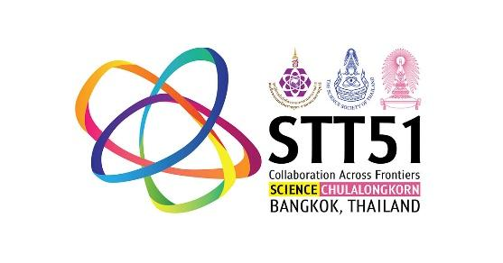

**The 2nd International Symposium of Science Communication and Public Science Literacy 2025**

as a part of the 51st International Congress on Science, Technology,

and Technology-Based Innovation (STT51)

**“Communicating Frontier Science in the Challenging Era”**

**12 November 2025**

Chulalongkorn University, Bangkok, Thailand

**PROPOSAL SUBMISSION FORM**

The proposal should be between 2 - 5 pages in English only. It may include one or more photos, figures, or tables as appropriate.

| **Name** |  |
| --- | --- |

| **Organization** |  |
| --- | --- |

| **Job title** |  |
| --- | --- |

| **Contact information** (email) |  |
| --- | --- |

* *The information above will be used to facilitate your participation in the symposium.*

***********************

**Detail of your proposal**

| **Title of your presentation/project (Maximum 15 words)** |
| --- |
|  |

| **Sharing theme** (Please ✓ the box below) | |
| --- | --- |
|  | Theme 1: Research and Scholarship |
|  | Theme 2: Practice and Public Engagement |

| **Authors and Affiliations** |
| --- |
|  |

| **Abstract/description of the project** (Maximum 200 words) |
| --- |
|  |

| **Concepts and objectives of the project** |
| --- |
|  |

| **Methodology: Project/research method and/or platform used in the project** |
| --- |
|  |

| **Key/pilot results** |
| --- |
|  |

| **Discussion: Barriers/concerns to the project and/or support needed** |
| --- |
|  |

| **Suggestions for the further project** |
| --- |
|  |

| **References** |
| --- |
|  |

**Please submit your proposal and abstract** via this link <https://forms.gle/rR3kWYY4SZAabdb18> **by September** **10, 2025, 11.59 PM (Bangkok Time)**

**For more details, please contact.**

Dr. Supa Tanprasertkun

Email: supa.t@nsm.or.th

Tel: (+66) 02 577 9999 ext. 1494

Dr. Wilasinee Triyarat

(Director of Research and Academic Service Division)

E-mail: wilasinee@nsm.or.th

Tel: (+66) 02 577 9999 ext. 1499

Ms. Patthama Nukhong

E-mail: patthama@nsm.or.th

Tel: (+66) 02 577 9999 ext. 1498

Ms. Chanoknan Koongsamoot

E-mail: chanoknan.k@nsm.or.th

Tel: (+66) 02 577 9999 ext. 1473

*For e-mail, please cc. joongghing@gmail.com and nstfairthailand@nsm.or.th